SunPass - Content Calendar

Priority | Image | Title & Link | Publication Date | Character Count | Link | Assigned To | Posted
 |  | SUNPASS SOCIAL MEDIA CONTENT CALENDAR
 |  | 2020 Posts
 |  | 2021 Posts
 |  | 2022 Posts
 |  | January 2022
 |  | February 2022
 |  | March 2022
 |  | April 2022
 |  | Week 1
 | 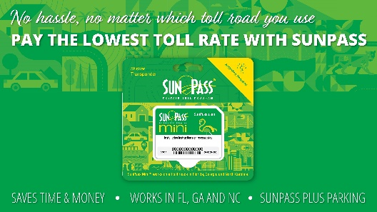 | Get a SunPass Mini for only $4.99 and start saving an average of 25% on tolls today! Visit SunPass.com to find out where to purchase your SunPass. (Use this link, https://www.sunpass.com/en/about/whereToPurchaseSunPass.shtml  Update to SunPass Mini graphic
 |  | Traveling through the new extension of the Suncoast Parkway/State Road (SR) 589? Get your SunPass today and start saving on tolls!
 |  | Week 2

Priority | Image | Title & Link | Publication Date | Character Count | Link | Assigned To | Posted
 |  | You can access your #SunPass account online 24 hours a day, 7 days a week to add funds, update your account information, submit a service request and more. Visit SunPass.com or download SunPass mobile app.
 |  | Happy Easter from SunPass!
 |  | Week 3
 |  | Celebrate Earth Day by switching your SunPass Statements to paperless! #EarthDay #GoGreen #GoPaperless  Update graphic to stay Statements not billing
 |  | Have one less thing to worry about with Easy Pay. Add a credit or debit card to your SunPass account and select Easy Pay. Learn more at SunPass.com (use this link, https://www.sunpass.com/en/about/cash.shtml )
 |  | Week 4

Priority | Image | Title & Link | Publication Date | Character Count | Link | Assigned To | Posted
 |  | Change the State of Driving and purchase your SunPass PRO today at SunPass.com, Florida's Turnpike Service Plazas, and select retailers.
 |  | SunPass puts you in the driver’s seat. Manage your account on the go with the FREE SunPass Mobile App.
 |  | May 2022
 |  | June 2022
 |  | July 2022
 |  | August 2022
 |  | September 2022
 |  | October 2022
 |  | November 2022
 |  | December 2022

