Central Polk Parkway/State Road 570B Extension Project
  - from U.S. 17/State Road 35 to State Road 60

Project Description
Florida’s Turnpike Enterprise (Enterprise) is extending Central Polk Parkway/State Road (S.R.) 570B from U.S. 17/S.R. 35 to S.R. 60 in Polk County. This new four-lane tolled roadway (two lanes in each direction) will improve connectivity throughout Polk County.

Project Benefits
- Increased Regional Access: Extending Central Polk Parkway approximately 2.6 miles to provide additional access to Interstate 4.
- Improved Traffic Flow: Supporting smoother travel by constructing a new interchange at U.S. 17, adding a signalized intersection at S.R. 60, and redirecting commuter and truck traffic.
- Enhanced Safety: Installing new roadway lighting, signage and pavement markings, guardrail, and wrong-way driving vehicle detection technology to promote safer and more efficient travel.
- Expanded Connectivity: Adding a multi-use trail adjacent to the new roadway, creating a safe and convenient route for pedestrians and cyclists while enhancing community access and recreation opportunities.

Construction and Traffic Impacts
Construction activities will occur during both daytime and nighttime hours. Nearby residents and businesses may experience occasional impacts from construction-related light, noise, vibration, or dust. The Enterprise is committed to minimizing these disruptions and takes steps to limit traffic delays and noise.
Lane closures will generally take place during off-peak hours to reduce impacts on drivers. Information about closures will be provided in advance through the Central and West Central Florida Weekly Lane Closures and Work Zone Advisory.

Schedule and Funding
Construction Schedule:
Work is anticipated to be completed by early 2031.
Project Cost:
The project cost is approximately $134 million.

Community Outreach

Brielle Gordon
Brielle.Gordon@dot.state.fl.us
www.FloridasTurnpike.com
X.com/FloridaTurnpike
Community Outreach Specialist
954-934-1279
1-800-749-PIKE

Project Map
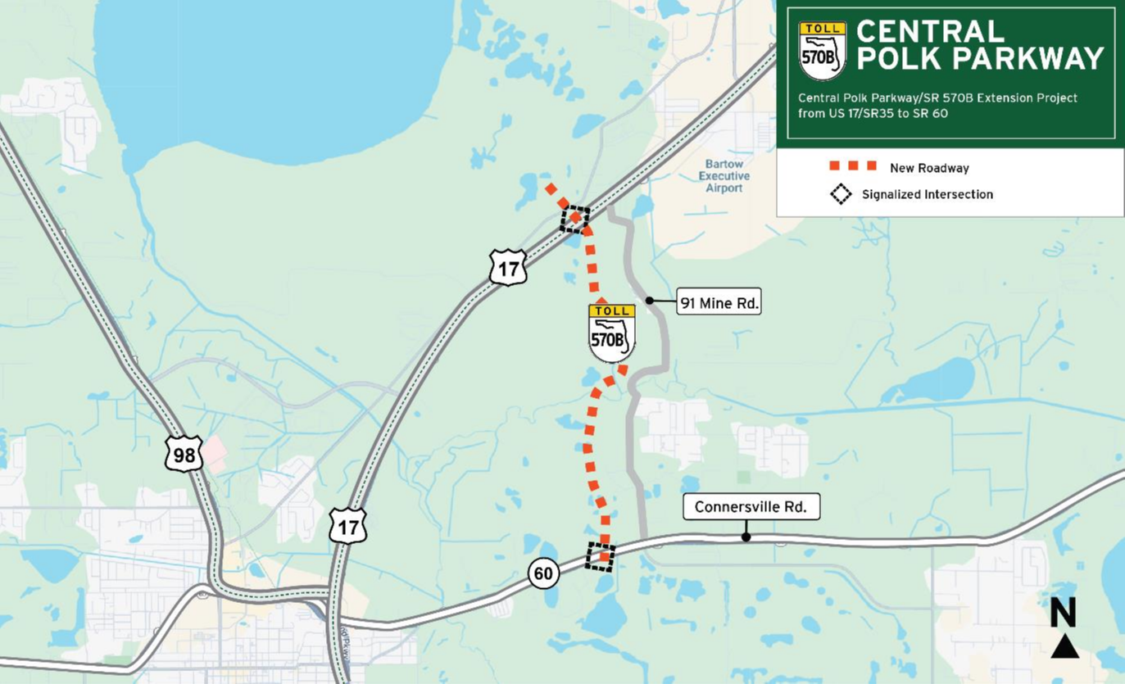
To receive construction updates via e-mail, please contact Brielle.Gordon@dot.state.fl.us.

