Northern Turnpike Mainline/S.R. 91 Widening Project from Clermont/S.R. 50 to Minneola/Hancock Road

Project Description
Florida’s Turnpike Enterprise is widening the Northern Turnpike Mainline from two to four lanes in each direction, from Clermont/State Road (S.R.) 50 to Minneola/Hancock Road (mileposts 273 to 279), in Lake and Orange Counties.

Project Benefits
- Widening the Turnpike bridges at Jones Road, Blackstill Lake Road, Old Highway 50, West Orange Trail, and Fosgate Road.
- Replacing the Turnpike bridges at County Road (C.R.) 438 and C.R. 455.
- Constructing new electronic tolling gantries and buildings and demolishing existing toll booths and canopies at the Clermont/S.R. 50 entrance and exit ramps.
- New signage, pavement markings, signalization, lighting, and drainage throughout the project.

Construction and Traffic Impacts
Construction will take place during both daytime and nighttime hours. Nearby residents and businesses may experience periodic construction light, noise, vibration, and dust through the project’s duration. The Enterprise takes steps to reduce construction impacts and efforts will be made to limit traffic and noise disruptions.

Lane closures will generally take place during off-peak hours to minimize traffic congestion and delays for most drivers. Closures will be announced in advance in the Central and West Central Florida Weekly Lane Closures and Work Zone Advisory.

Schedule and Funding
Construction Schedule:
Work is anticipated to continue through mid-2026.
Project Cost:
The project cost is approximately $162.3 million.

Community Outreach

Russ Handler
Russ.Handler@dot.state.fl.us
www.FloridasTurnpike.com
X.com/FloridaTurnpike
Community Outreach Specialist
407-264-3159
1-800-749-PIKE

Project Map

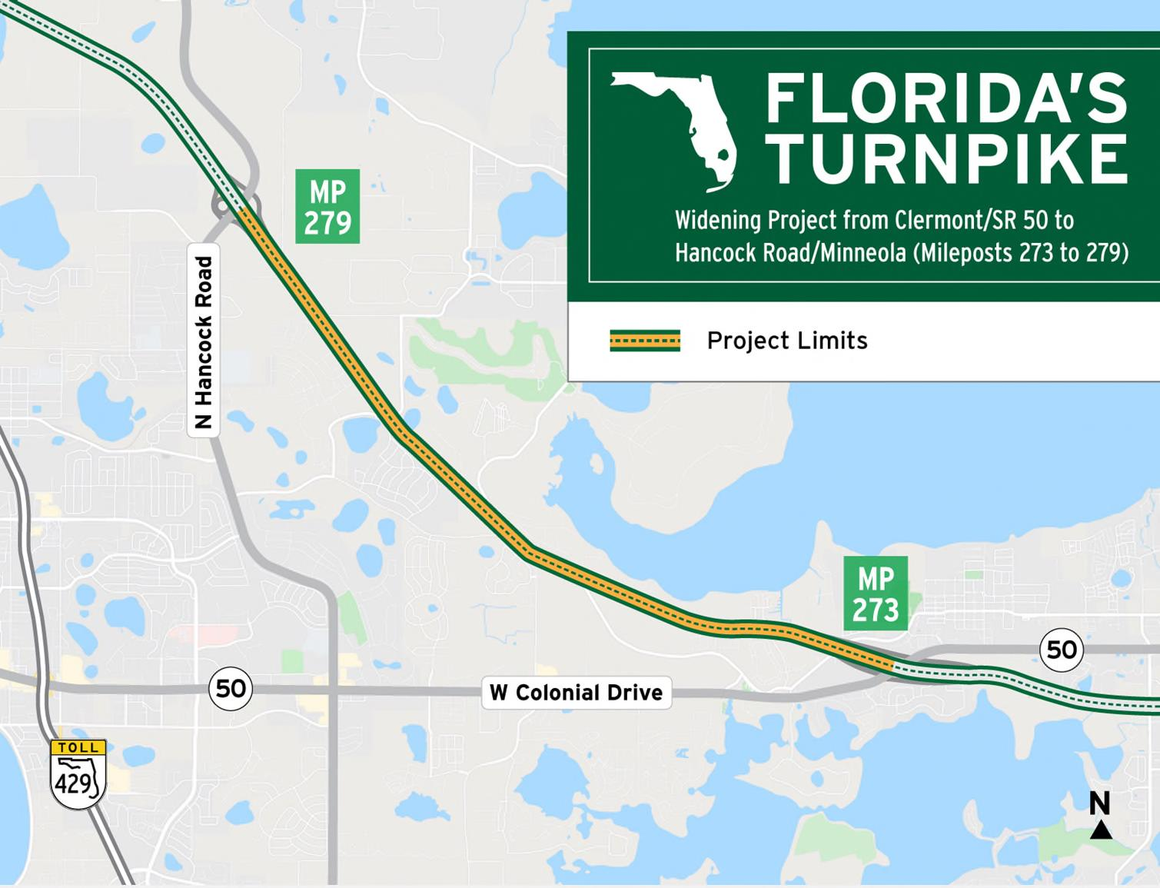
To receive construction updates via e-mail, please contact Russ.Handler@dot.state.fl.us.

