Florida’s Turnpike and Sand Lake Road/State Road 482 Interchange Development Project

Project Description
Florida’s Turnpike Enterprise is constructing a new interchange at Florida’s Turnpike and Sand Lake Road/State Road (S.R.) 482 in Orange County.

Project Benefits
- Enhancing connectivity by constructing a new interchange at Sand Lake Road to meet current and future traffic demands.
- Increasing roadway longevity and durability with the reconstruction of the Sand Lake Road bridge to accommodate the new ramps.
- Strengthening safety by signalizing the ramp intersections connecting Sand Lake Road to Florida’s Turnpike.
- Improving traffic flow by enhancing the intersection of President’s Drive and Sand Lake Road.
- Supporting pedestrian accessibility by providing sidewalks from John Young Parkway to Presidents Drive.
- Supporting economic growth by improving the transportation infrastructure in the area.

Construction and Traffic Impacts
Construction will take place during daytime and nighttime hours. Nearby residents and businesses may experience periodic construction light, noise, vibration, and dust. The Enterprise takes steps to reduce construction impacts and efforts will be made to limit traffic and noise disruptions.
Lane closures will generally take place during off-peak hours to minimize traffic congestion and delays for most drivers. Closures will be announced in advance in the Central and West Central Florida Weekly Lane Closures and Work Zone Advisory.

Schedule and Funding
Construction Schedule:
Work is anticipated to be completed by late 2027.
Project Cost:
The project cost is approximately $114.6 million.

Community Outreach

Laura Spencer
Laura.Spencer@dot.state.fl.us
www.FloridasTurnpike.com
X.com/FloridaTurnpike
Community Outreach Specialist
407-264-3159
1-800-749-PIKE

Project Map

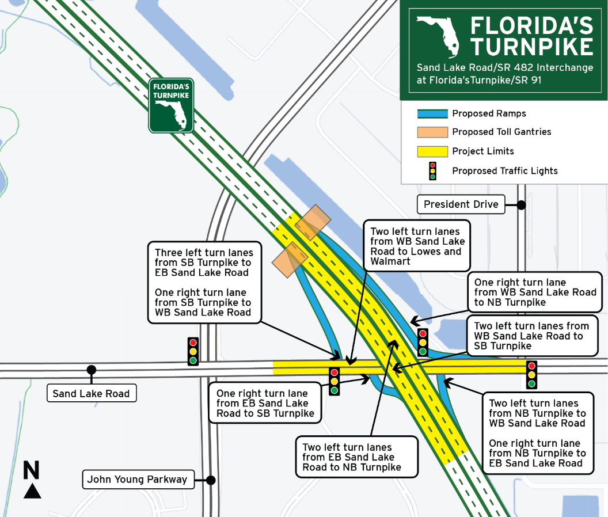
To receive construction updates via e-mail, please contact Laura.Spencer@dot.state.fl.us.

